Aulacoseira granulata (Ehrenberg) Simonsen 1979
Previous name used: Melosira granulata (Ehrenberg) Ralfs 1861
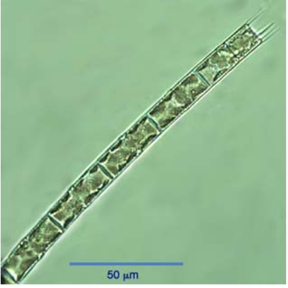
Phylum: Bacillariophyta
Class: Melosirophyceae
Order: Melosirales

Habitat: plankton, benthos
Distinctive features: filamentous, abundant in winter, sharp spines at end cell.
Organization: filamentous
Color: golden-brown
Cell shape: cylinder
Colony shape: filament, made of a chain of cylindrical cells
Cell diameter (D): 9-16 µm (median 12.6) (N=241).
Cell length (L): 27-37 µm (median 31 µm).
Cell biovolume: 2000-9000 μm³, median: 4000 μm³.
Biovolume equation: Cylinder, V = 2 π L (D/2)². Or: regression eqn. based on >500 measurements of both D and L with V computed for a cylinder: V=50.538D^{1.7197}).
Filament length: 150-900 µm (median: 400 µm). Longer filaments in winter, shorter in summer (see Fig. 2b).
Cells per filament: 5-28 (median: 14)
Indicator species: oligohalobious-indifferent, alkaliphilous, oligosaprobic to mesosaprobic, inhabits eutrophic waters. The variety angustissima is an indicator of greater water eutrophication. It is oligohalobious-indifferent, alkaliphilous, mesosaprobic (Ehrlich 1995).

Morphological features:
A filamentous centric diatom, with cylinder-shaped cells, interconnected by means of delicate spines in one cell that interlock into matching grooves in the neighboring cell. The spines can be seen in end-cells (Plate 1a, c) and are diagnostic of the species. Each cell is made of two valves that fit into each other like the two parts of a petri dish. In lake Kinneret, cell diameter ranges 9-16 µm (median 11.5), cell length 27-37 µm (median 31 µm); the filaments are straight, with 5-28 cells per filament. The valves are decorated with rows of areoles (perforations), 9-15 such rows (= striae) per 10 µm, straight or slightly curved (Plate 1b, c, e). Straight and curved striae may occur together on adjacent cells of a single filament or even in one cell. The areoles vary greatly in size. In Lake Kinneret the filaments are always straight, the curled morphotype is absent.
Under light microscope A. granulata frustules are usually seen in girdle view, showing the long, straight filaments (Plate 1). Aulacoseira granulata is polymorphic regarding size, diameter/length ratio and striation. Strongly silicified forms with coarse, irregularly spaced areoles are termed Aulacoseira (Melosira) granulata var. valida (Hustedt) Simonsen 1979. In Lake Kinneret intermediate forms between this variety and the nominate are frequent (Ehrlich 1995).
Vegetative cell division is the asexual, ordinary way of Aulacoseira granulata reproduction. Cell division results in progressively smaller frustules until a specific minimum valve diameter is attained. A reestablishment of the maximum size is then achieved by sexual reproduction with auxospore (zygote) formation (Plate 1b; O’Farrel et al. 2001). The huge auxospore of A. granulata “resets” the cell size for the next growing season. In Lake Kinneret Aulacoseira granulata auxospores were seen rarely.

A variety of the species found in Lake Kinneret is Aulacoseira granulata var. angustissima (O.F. Müller) Simonsen 1979 (Plate 1d). This variety differs from the nominate variety by its very narrow valve. Cell diameter < 4 µm (as opposed to 9-16 µm in the nominate variety), cell length 12 – 25 µm, diameter/length ratio is about 1/5 – 1/8 (Ehrlich 1995).

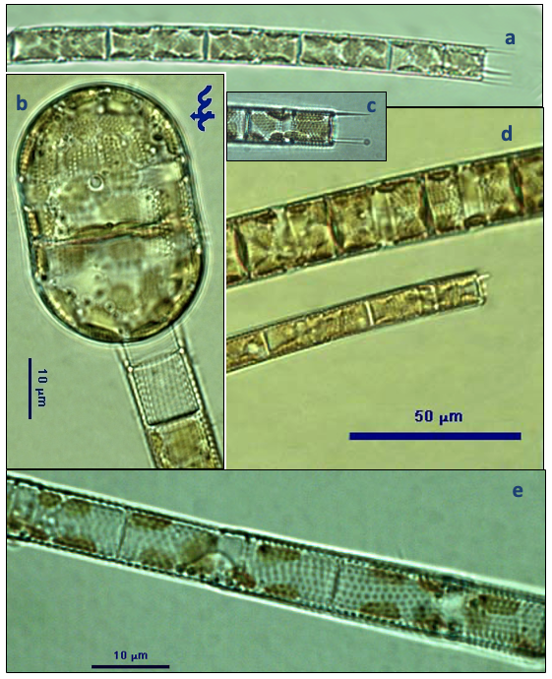
Plate 1. Aulacoseira granulata from Lake Kinneret. (a) A typical actively growing planktonic filament, with equal length marginal spines at the perimeter of the end-cell, these are the so-called linking spines which hold adjacent cells together. The chloroplasts fill the entire cells. (b) Auxospore (made by sexual reproduction) at the end of a filament. (c) End cell with apical spines. (d) Aulacoseira granulata (thick filament) next to Aulacoseira granulata var angustissima (thin filament). (e) A filament that was resuspended from the sediments not long before sampling. The chloroplasts are compacted and do not fill the entire cell volume. Photos by Alla Alster.

Ecology:
The species is one of the most common diatoms of Lake Kinneret, with peak abundance during winter holomixis (Jan-Feb) when it occupies the entire 40 m water column. Major A. granulata blooms were recorded in Jan-Feb 1988; 1999; 2001 (Fig. 1). This is the only species in Lake Kinneret besides Peridinium gatunense that ever-reaches depth-integrated biomass exceeding 100 g m⁻² and on 3 occasions > 250 g m⁻² (Fig. 1). In recent years its abundance has declined.
The strongly silicified forms of Lake Kinneret A. granulata require optimal turbulence to maintain them in the fully mixed water column in winter (Ehrlich 1995). Once stratification sets off in March, they sink to the sediments and rest there in a dormant form with compressed chloroplasts (Plate 1e) till resuspended with turnover in the following winter (Fig. 2c). A strong negative relationship exists between cell-diameter and cell-length (R² = 0.37 on field material; Fig. 2a). Filament size is highly variable; most filaments will contain between 5 and 28 cells (Fig. 2b). Filament size shows a strong seasonal pattern, being largest in winter, smallest in summer (Fig. 2d). Zohary et al. (2017) hypothesized that this seasonal pattern may be to reduce sinking rates in winter.
The need for Si for its frustule is apparent: during blooms the Si concentration in the epilimnion of Lake Kinneret declines dramatically (Fig. 3). But it never declines below 4 mg L⁻¹, suggesting that another factor causes the bloom decline.
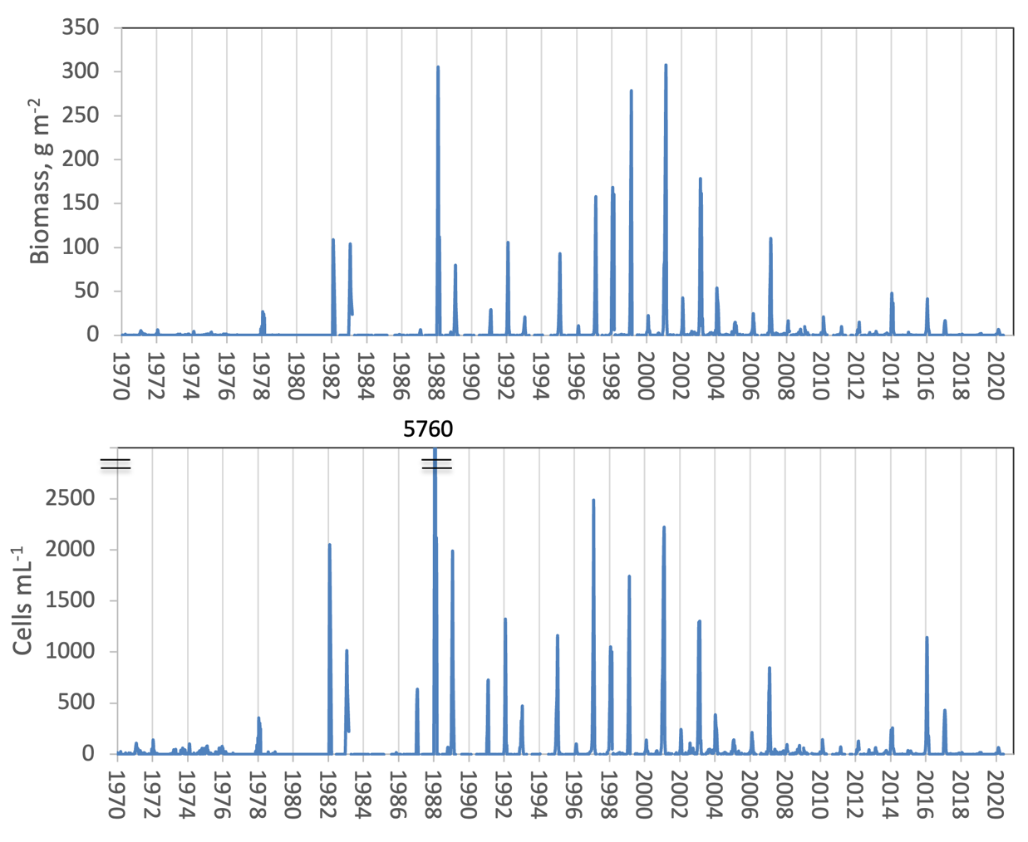
Figure 1. Time series of Aulacoseira granulata depth-integrated wet-weight biomass (g m⁻², upper panel) and mean epilimnion cell abundance (cells mL⁻¹, lower panel), Lake Kinneret, 1970-2020.

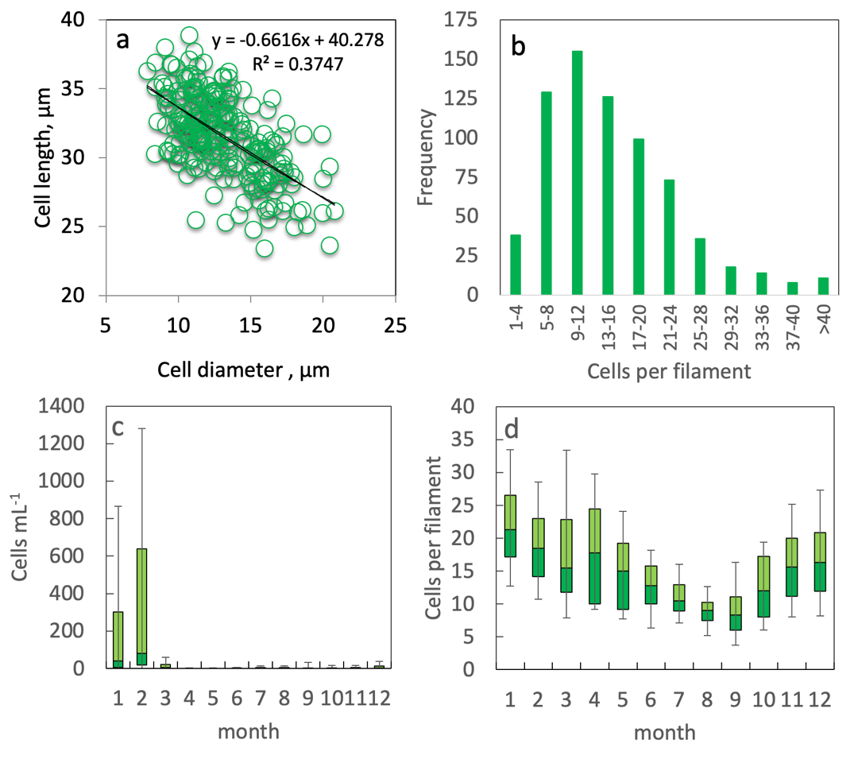
Figure 2. Morphological characteristics and seasonal patterns in Aulacoseira granulata: (a) the negative relationship between cell diameter and cell length; (b) frequency distribution for the number of cells per filament; (c) the annual cycle of cell abundance; (d) the annual cycle of the number of cells per filament. Data are for field populations from Lake Kinneret, 1982-2020.
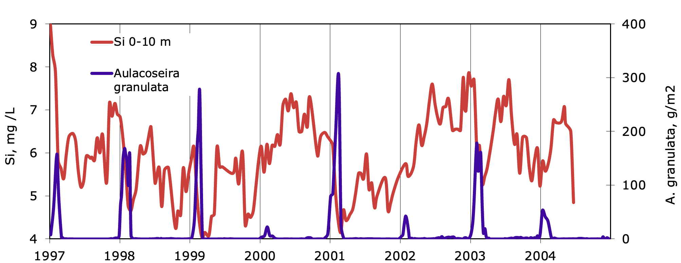
Fig. 3. Time series of A. granulata biomass and Si concentration (0-10 m average), Lake Kinneret at Sta. A, 1997-2004, showing a sharp decline of Si in winters with a substantial A. granulata bloom, but that Si never declines below 4 mg L⁻¹.
Internationally, this cosmopolitan species is widespread in the phytoplankton of lakes, ponds, reservoirs and rivers. It is typical of carbonate-rich, moderately eutrophic to eutrophic waters. It is used as indicator species of water with relatively low salts concentrations, pH < 9, and high silica concentrations. The variety angustissima is rare in Kinneret compared to the nominate variety. It is known to be mesosaprobic, common in more eutrophic water bodies than the nominate variety, indicator of water eutrophication.
Physiological features:
Monitoring data (cell abundance, chlorophyll concentrations, primary production) from bloom events, when A. granulata biomass contributed > 60% of total phytoplankton biomass, were used by Yacobi & Zohary (2010) to derive the physiological parameters given in Table 1. Notably, A. granulata exhibited particularly low assimilation numbers and long turnover times. This species grows relatively slowly.
Table 1. Physiological parameters for A. granulata based on field measurements
Physiological parameter | Average ± SD | N
C:Chl ratio | 26 ± 11 | 87
Assimilation number (at depth of max photosynthesis), mgC mg Chl⁻¹ h⁻¹ | 2.0 ± 0.4 | 7
Turnover time, d | 1.5 ± 0.7 | 7

Environmental conditions:
A. granulata is an indicator species of water with low concentrations of salts, pH less than 9 (Talling and Talling 1965) and high silica concentration (Kilham 1971). This species occurs in Lake Kinneret when water temperatures are below 18⁰C, at short wave radiation levels <200 Watt m⁻², at conductivity > 1000 μS cm⁻¹ and Cl⁻ concentrations spanning most of the range observed but not exceeding 300 mg L⁻¹. Its higher abundances occurred at Ca concentration >45 mg L⁻¹, alkalinity >120 mg CaCO₃ L⁻¹, at the higher levels of total dissolved phosphorus, nitrate and ammonium recorded in the lake, and at pH below 8.8.
Cite this record as:
Tamar Zohary, Alla Alster. [Date when Item was last updated]. Electronic publication. Israel Oceanographic & Limnological Research. [Date when last accessed].
Further reading:
Ehrlich A. 1995. Atlas of the inland-water diatom flora of Israel. Flora Palaestina. Jerusalem: The Israeli Academy of Sciences and Humanities, 166 pp.
Kilham P. 1971. A hypothesis concerning silica and the freshwater planktonic diatoms. Limnology and oceanography. 16:8-10.
Kilham SS, Kilham P. 1975. Melosira granulata (Ehr.) Ralfs: morphology and ecology of a cosmopolitan freshwater diatom. Internationale Vereinigung für theoretische und angewandte Limnologie: Verhandlungen. 19(4):2716-21.
O’Farrell I, Tell G, Podlejski A. 2001. Morphological variability of Aulacoseira granulata (Her.) Simonsen (Bacillariophyceae) in the Lower Parana River (Argentina). Limnology 2: 65-71.
Pollingher U. 1986. Phytoplankton periodicity in a subtropical lake (Lake Kinneret, Israel). Hydrobiologia 138:127-138.
Talling JF, Talling IB. 1965. The chemical composition of African lake waters. Internationale Revue der gesamten Hydrobiologie und Hydrographie. 50: 421-463.
Yacobi YZ, Zohary T. 2010. Carbon:chlorophyll a ratio, assimilation numbers and turnover times of Lake Kinneret phytoplankton. Hydrobiologia 639:185-196.
Zohary T, Fishbein T, Shlichter M, Naselli-Flores L. 2017. Larger cell or colony size in winter, smaller in summer – a pattern shared by many species of Lake Kinneret phytoplankton. Inland Waters 7(2): 200-209.

